### Attenuator

#### Description

This module reduces the signal that goes inside. The more you turn the knob down the more the signal is attenuated. Works as a volume knob for audio signal and an attenuator with CV input (it reduce the voltage).

We chose a 100k potentiometer as it works well with sound signal but feel free to change the value as you need (the higher resistance, the more the signal is attenuated).

#### Schematics

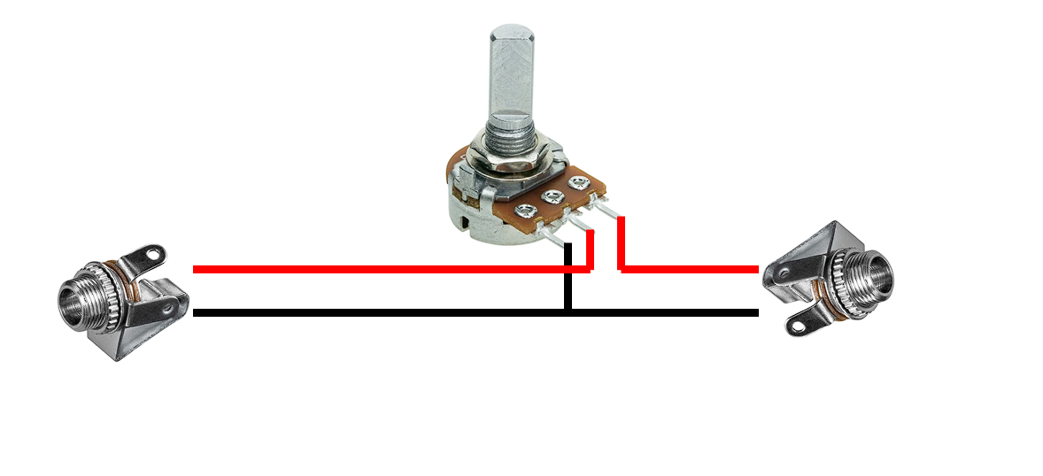

#### Liste des composants :

|  |  |
| --- | --- |
| Composant | Quantité |
| Jack | 2 |
| Potentiomètre 100k Ohm | 1 |